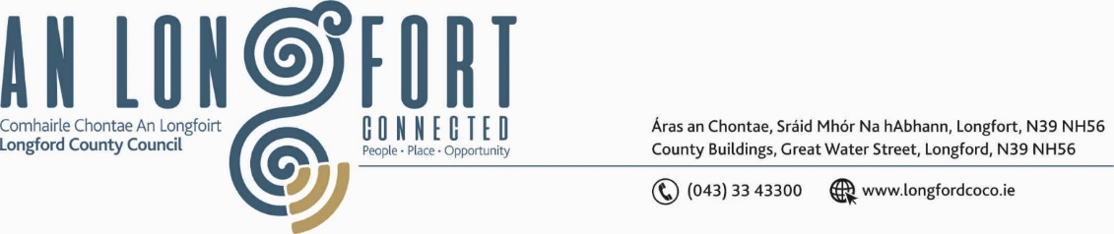

***LONGFORD MUNICIPAL DISTRICT***

***Please note meeting will be held via Microsoft Teams.***

**22nd April 2021.**

**To: Each Member of Longford Municipal District.**

**Dear Member,**

You are requested to attend the Meeting of Longford Municipal District to be held

**via Microsoft Teams** on **Wednesday 28th April 2021 at 4.30 p.m.** to transact business, as set out on the Agenda hereunder.

**Yours sincerely**,

Ann Marie Mc Keon

_______________

**Ann Marie Mc Keon**

**Meetings Administrator.**

**AGENDA**

Prayer before meeting.

**1.** Confirmation of Minutes:

(a) Longford Municipal District Meeting held on the 24th March 2021 – copy

enclosed.

(b) Longford Municipal District Committee Meeting held on the 24th March 2021

– copy enclosed.

**2.** Matters arising from Minutes.

**3.** Declaration of Interest by Members.

**4.** Management Report - enclosed.

**5.** Consideration of three applications for funding under the 2021 Community Grant

Support Scheme - list enclosed

6. Consideration of Adoption of Part 8, No. 84, R198 Battery Road Rehabilitation Scheme

at Battery Road, Longford Report in Accordance with Section 179 of the Planning and

Development Act 2000 (as amended) and Part 8 of the Planning & Development Regulations 2001 (As Amended) – details enclosed.

**7. Notices of Motions, submitted by Councillors, as listed hereunder –**

**Councillor John Browne**

“In Interest of safety I call on Longford County Council to have the damaged section of the R198 roadway, repaired and overlaid between Cahanagh Cross and the Creenagh Lane.

The road on one side has deteriorated following various repairs carried out, arising from bursts in the mains water pipe over the past few years and recent pipe laying along the other side of the main road is leading to subsidence.”

**Councillor Seamus Butler**

‘That Longford Municipal District will provide whatever civil works and assistances that are required to mount the Squirrel statue prototype provided by the Mide Arts Group in Newtownforbes’

**Councillor Seamus Butler**

‘Could we please have an update on the taking in charge of Leader Park’

**Councillor Uruemu Adejinmi**

“I call on Longford County Council to extend the footpath on Knockmartin Lane to the N4 and link it to the Drumlish road to form a loop and create a safe walking route for residents.”